**Lambda and image clean-up lab**

Today all pictures come with metadata like GPS info, camera, etc. Here is a useful function to clean-up it and keep some of our privacy.

1. Download the lab files from this repository:

<https://github.com/Resistor52/hitc-dev/blob/main/lab2.4/lambda_function.zip>

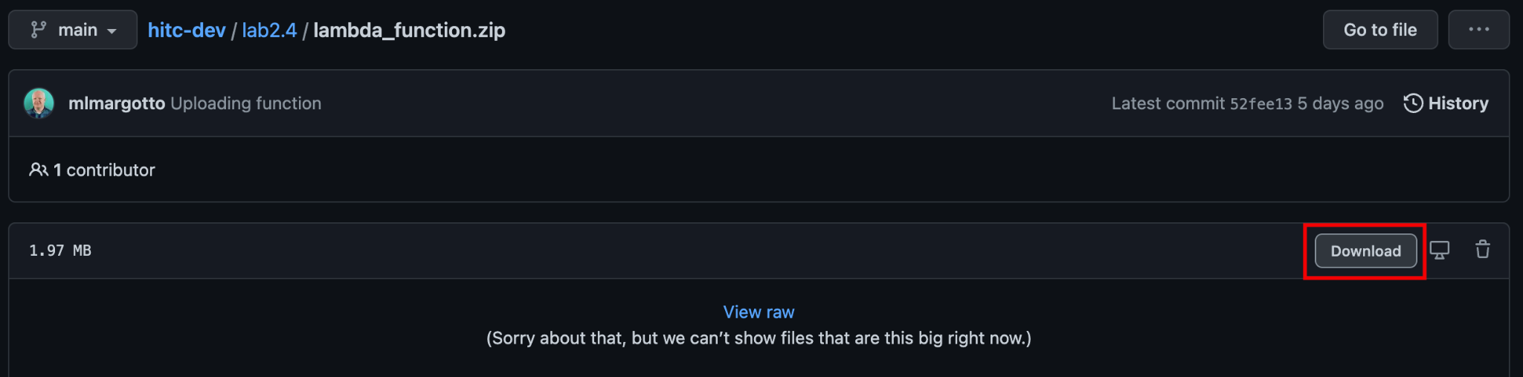

1. From AWS Management Console, time to create the buckets that will be used for our function. Create one called "input-image-<myPhoneNumber>" and another called "output-image-<myPhoneNumber>" using the procedure below.

Important - The buckets should start with the requested names, otherwise the clean up script will not work.

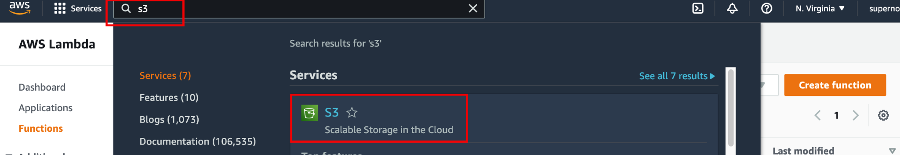

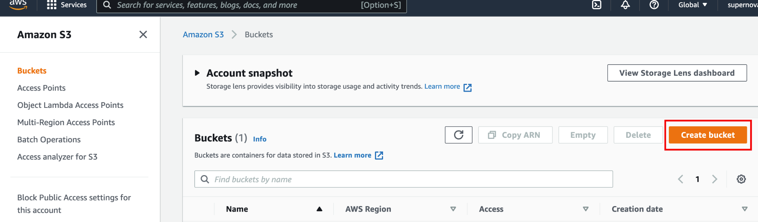

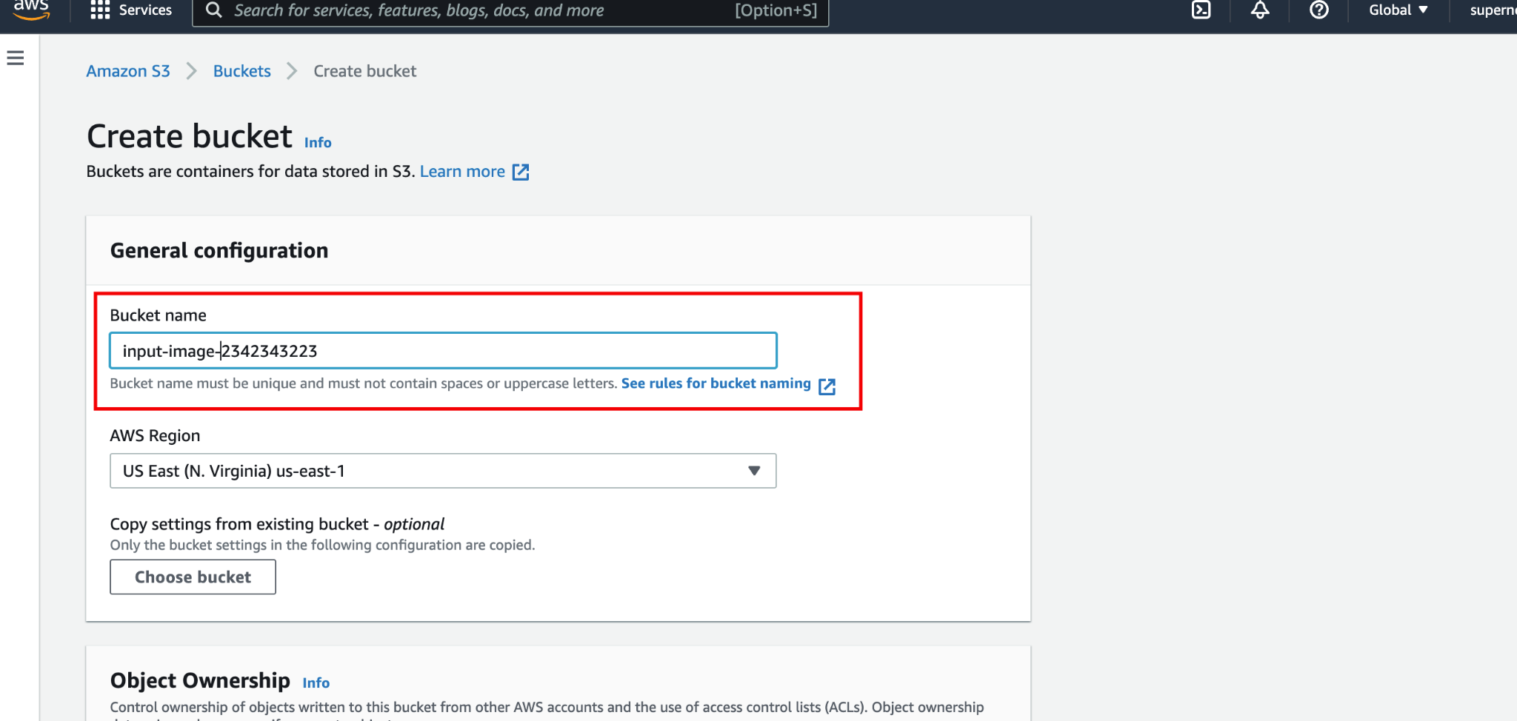

Enable encryption by default and click in Create Bucket.

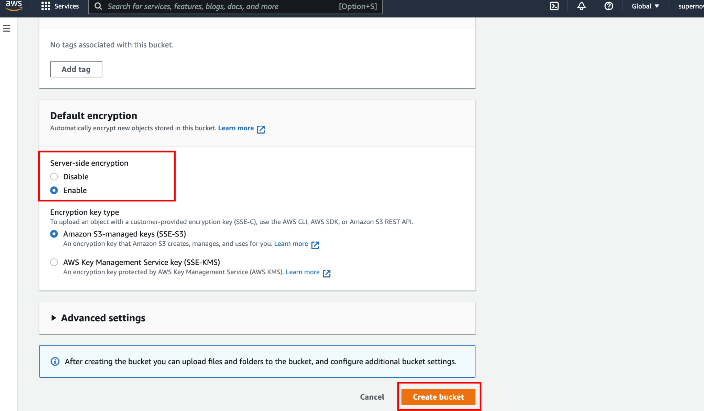

Repeat this step for output bucket.

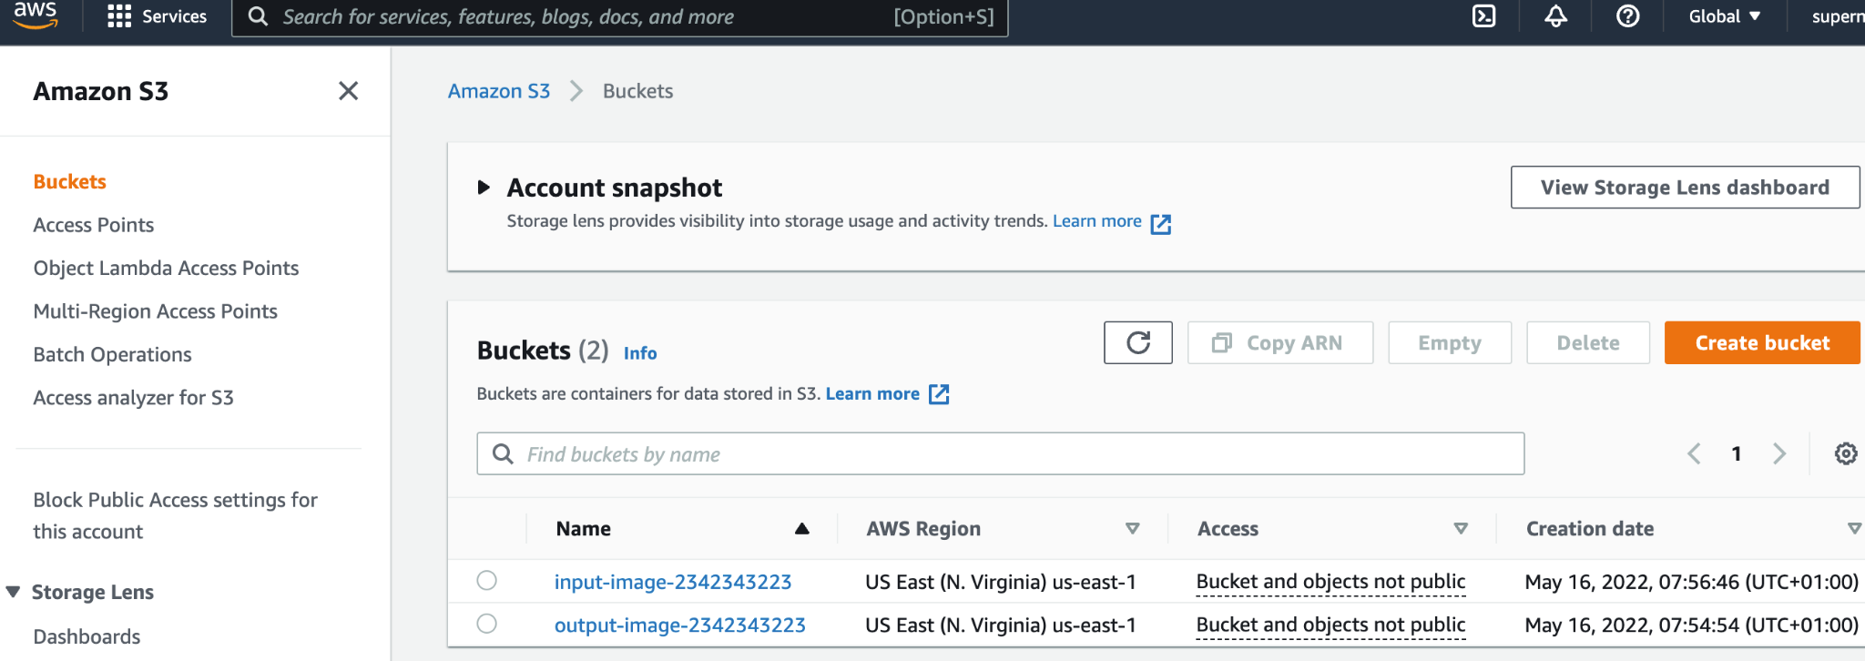

Info - As S3 uses the global unique bucket, two students can't use the same bucket name.

1. Create a custom policy available in https://github.com/Resistor52/hitc-dev/blob/main/lab2.4/s3_policy.json to add necessary permissions for the file transformation lambda function..

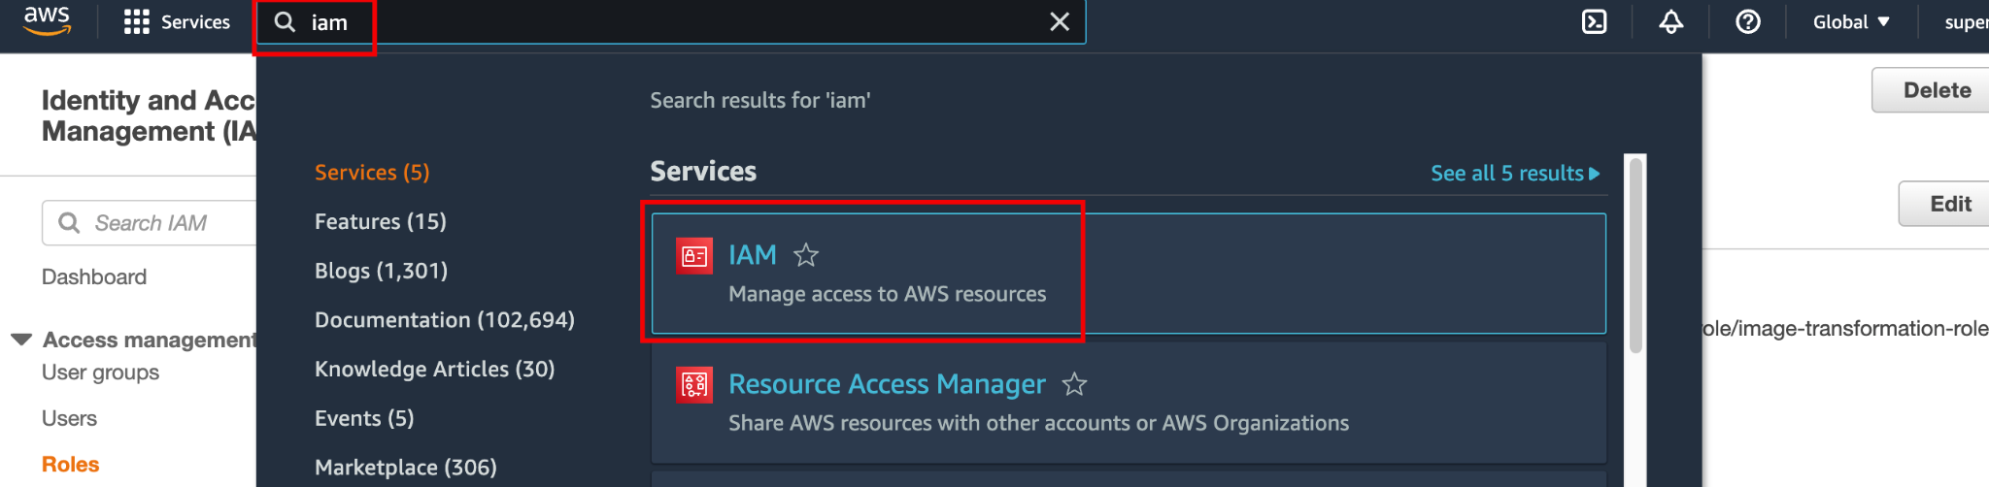

Select Policies

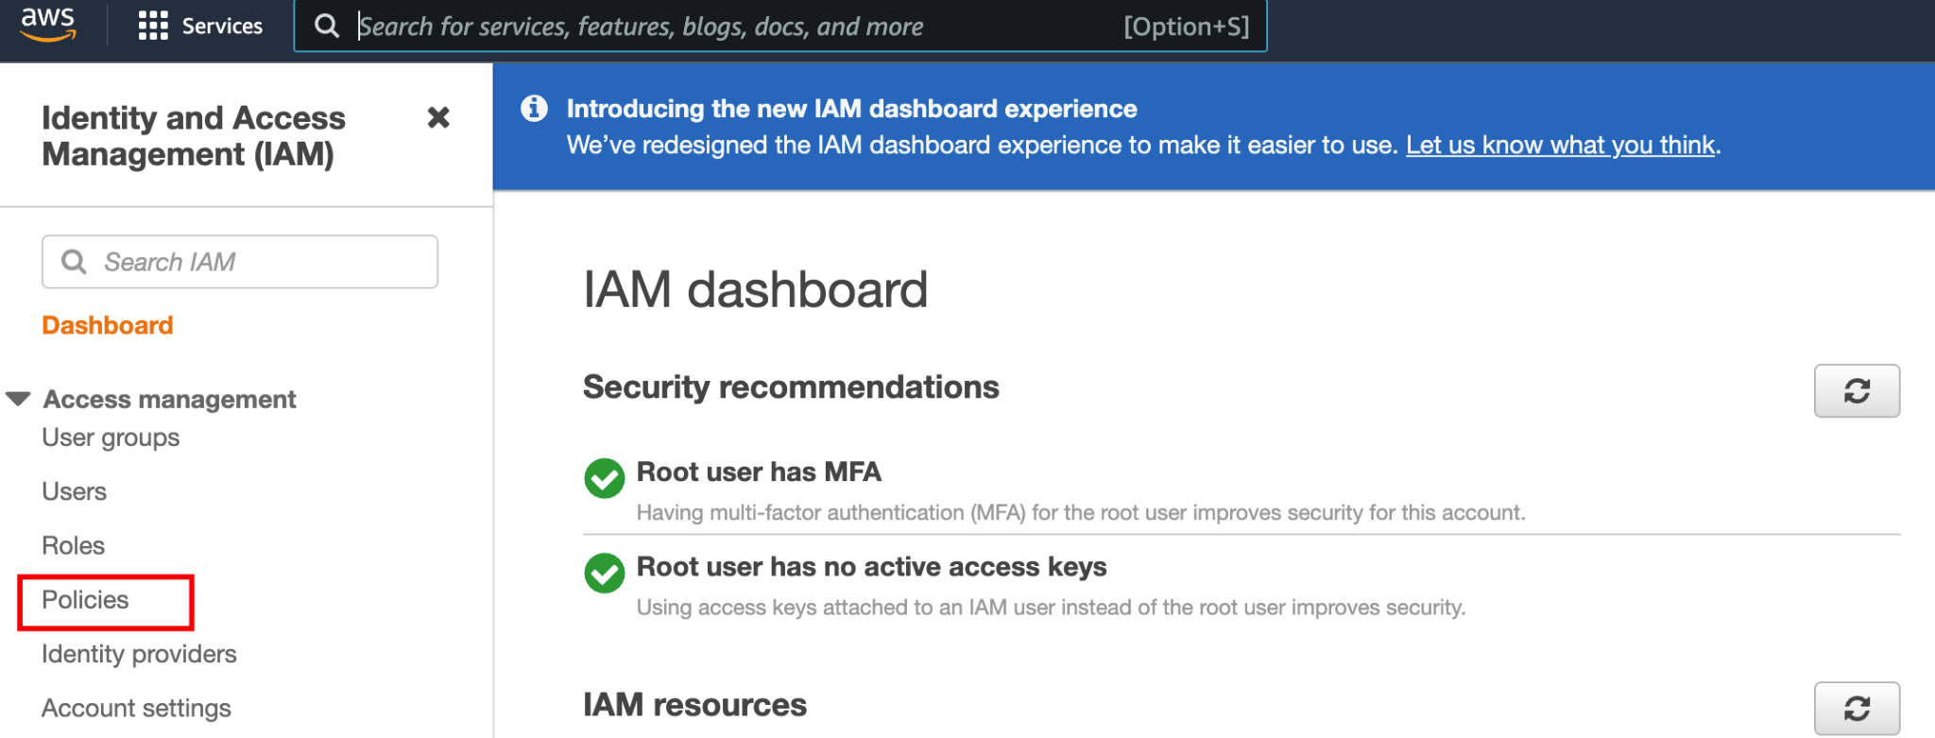

Select Create policy

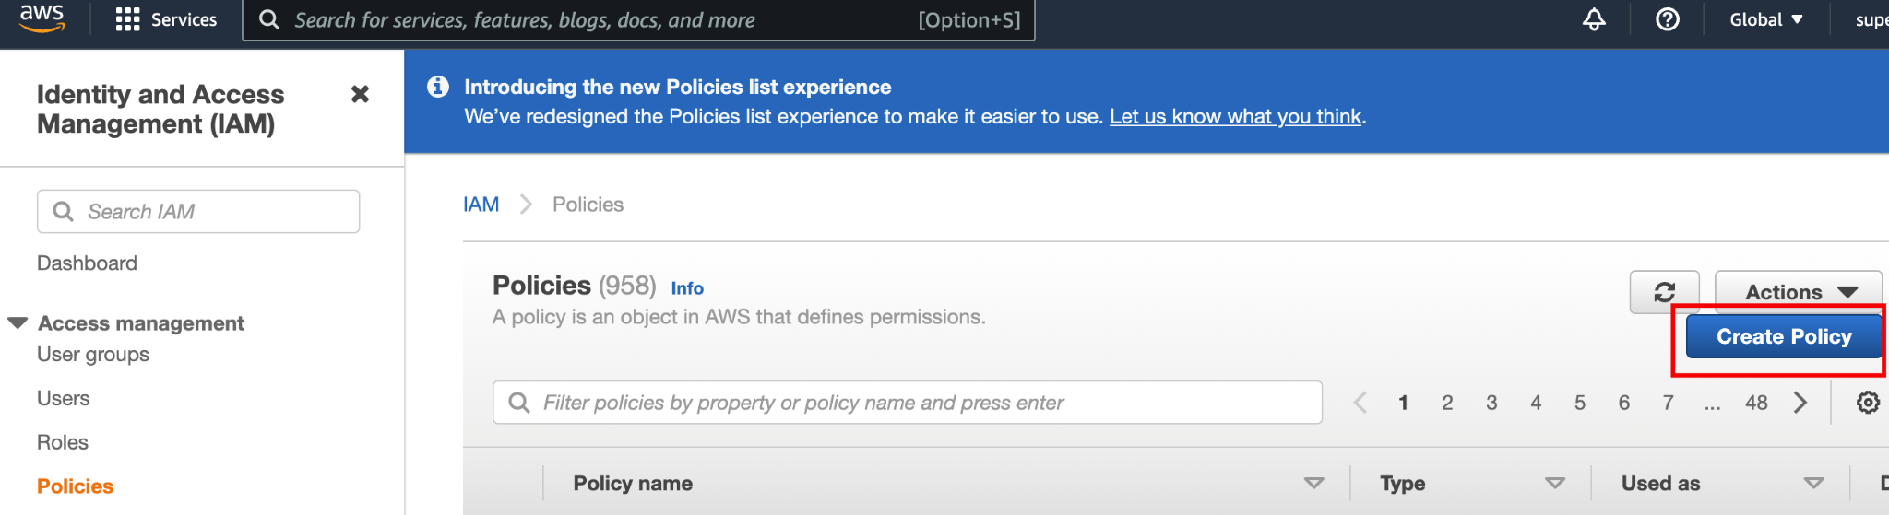

Click in JSON file and paste the file content available in the json file previously downloaded.

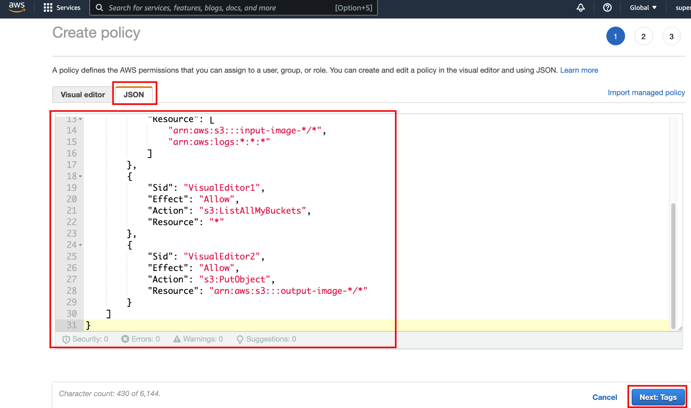

Click in Next review

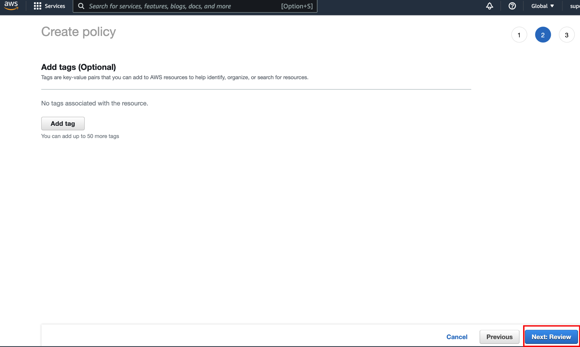

Type the policy name and click in Create policy

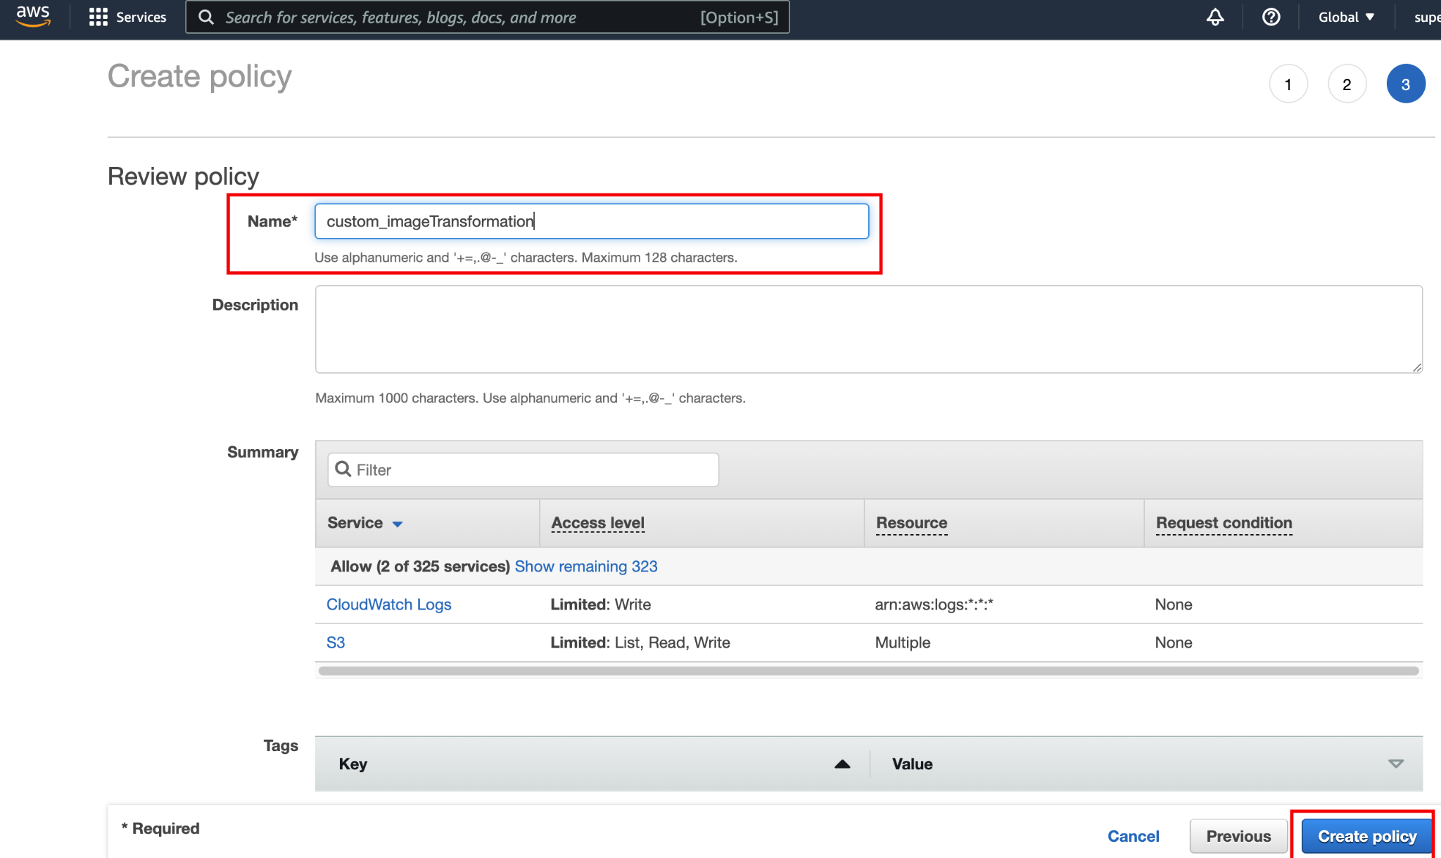

1. Create the lambda function that will be used to clean up the image when it is uploaded:

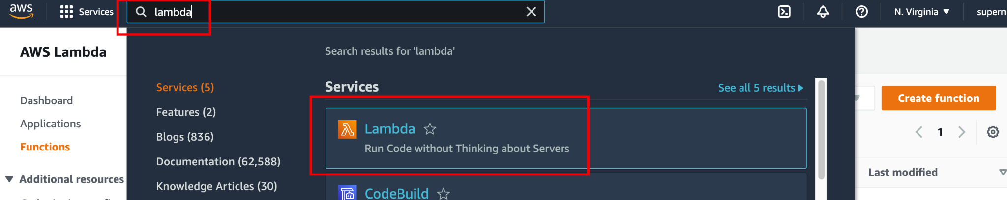

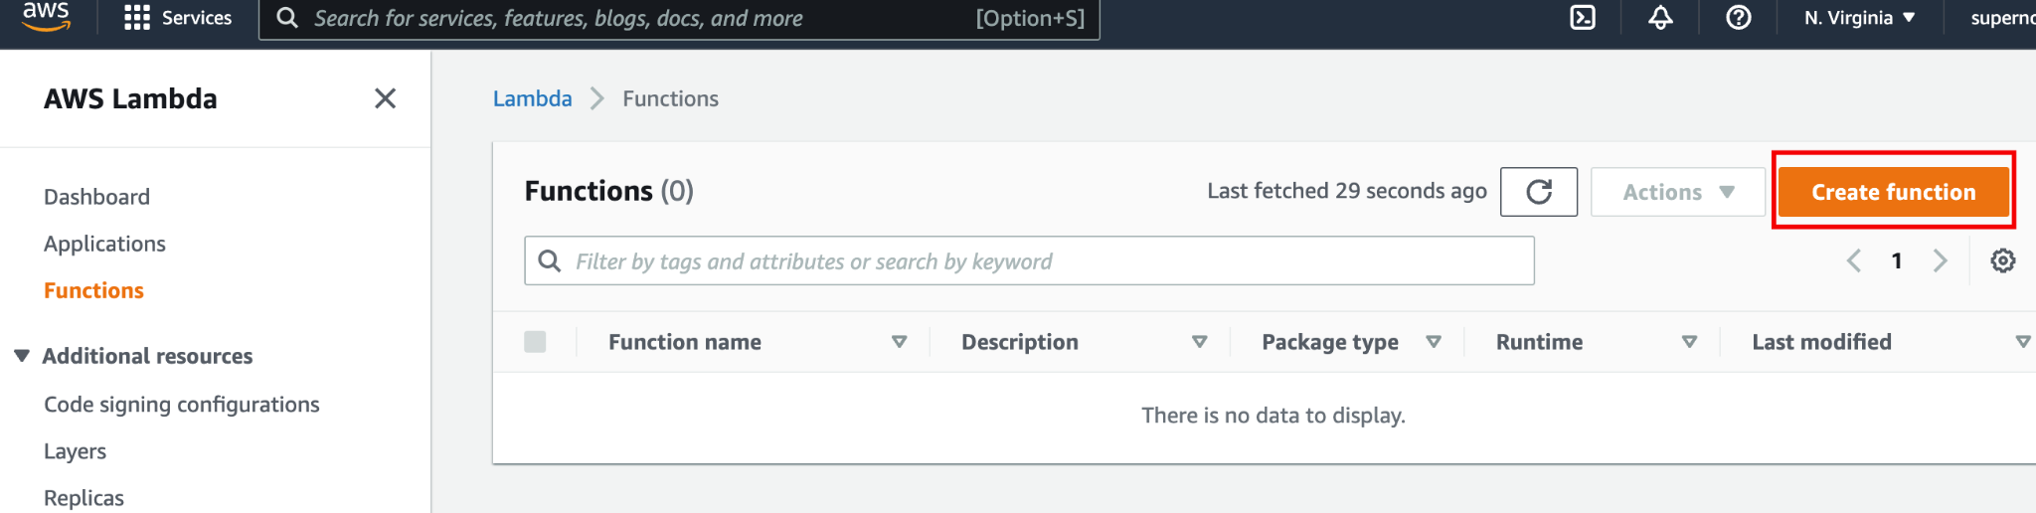

Select Use a blueprint and type s3-get-object-python.

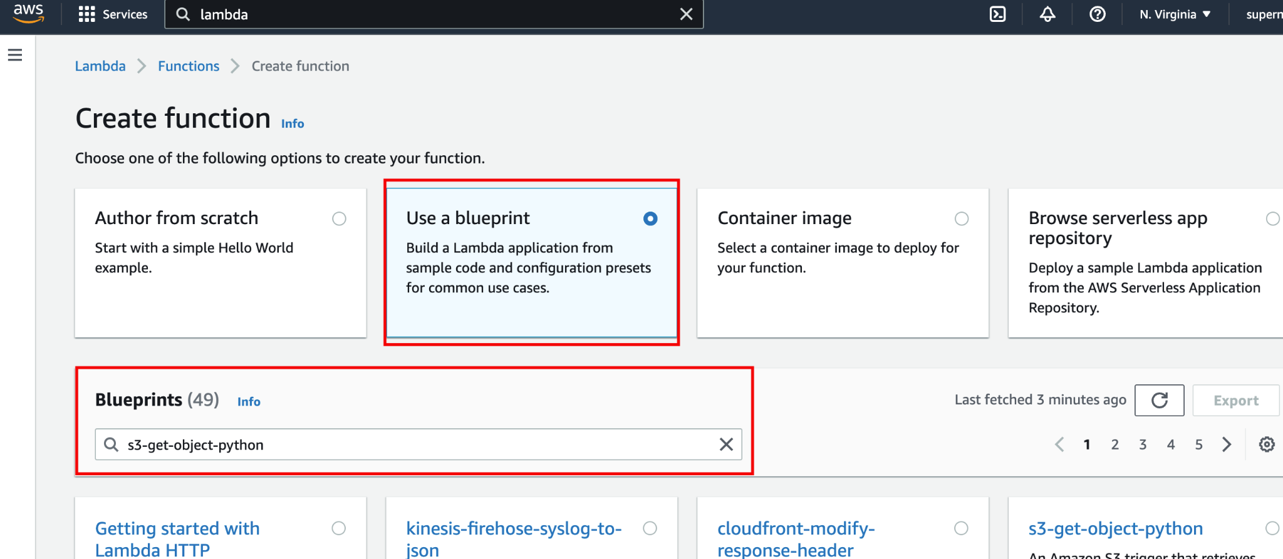

Select the available blueprint and click in configure.

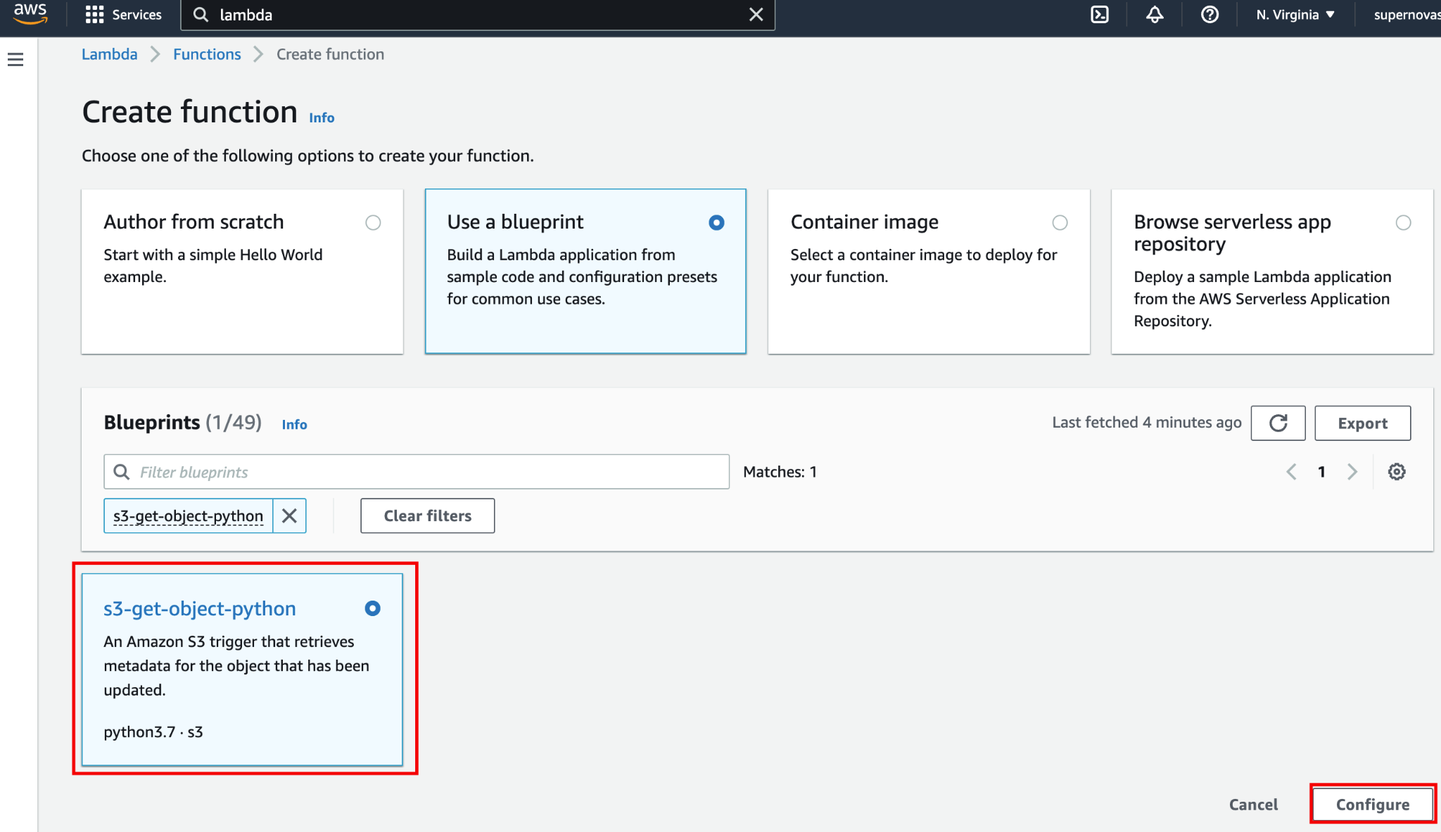

Add a function name and select Create a new role with basic Lambda permissions

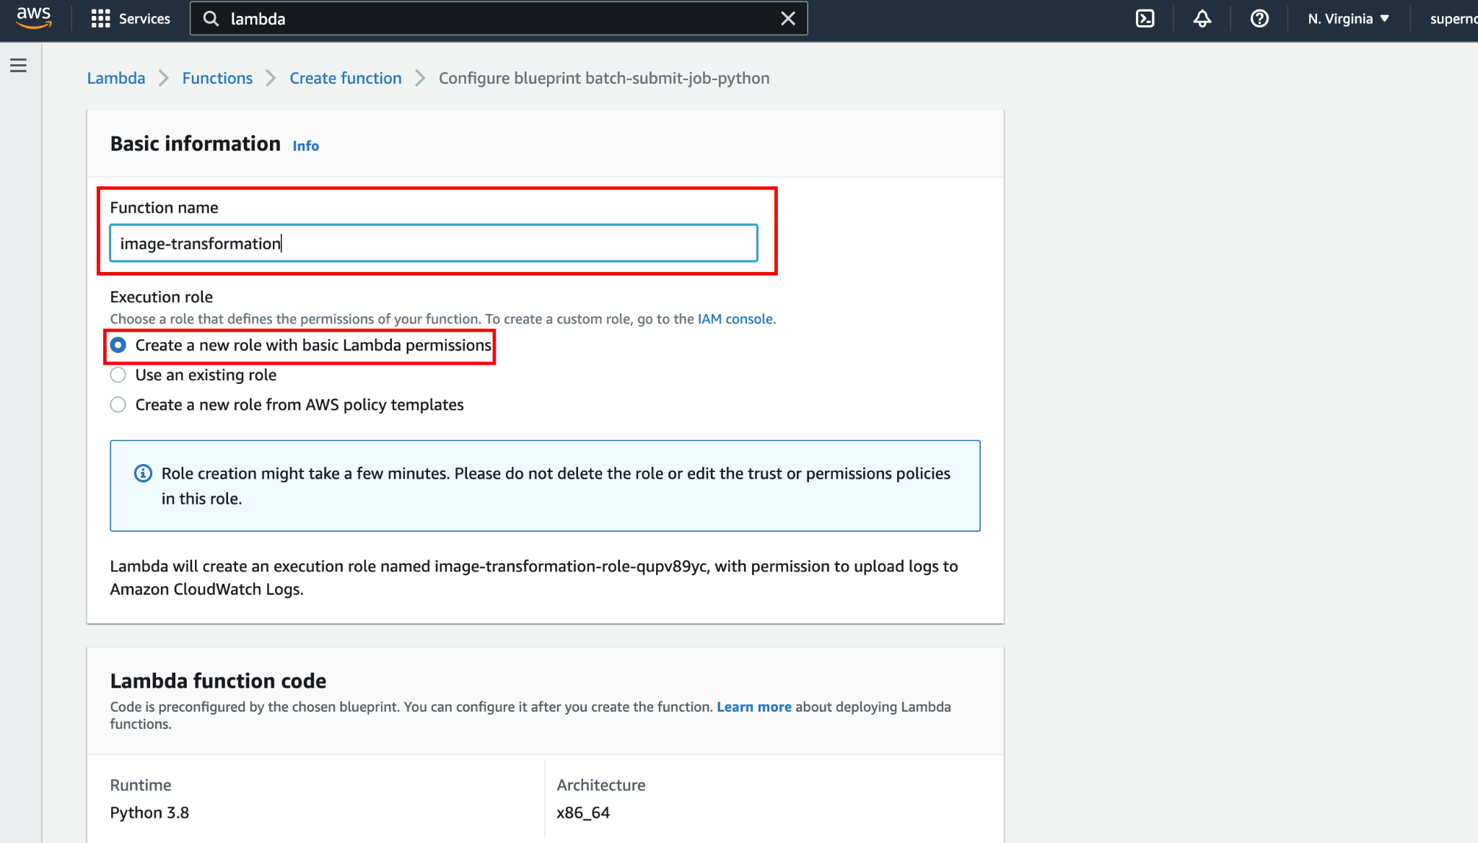

Scroll down and select Create function

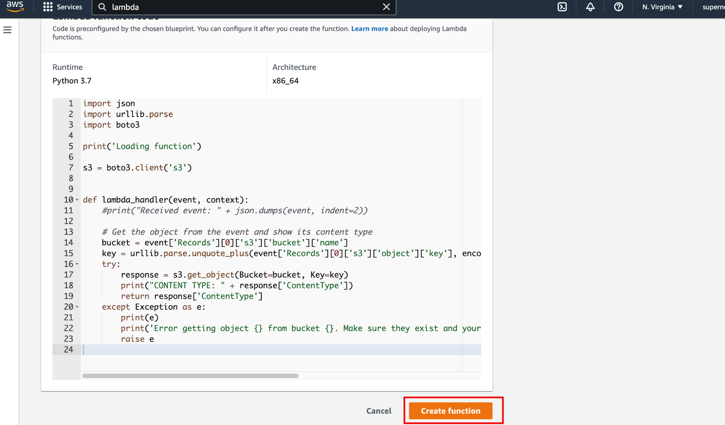

Now click in the function to configure it.

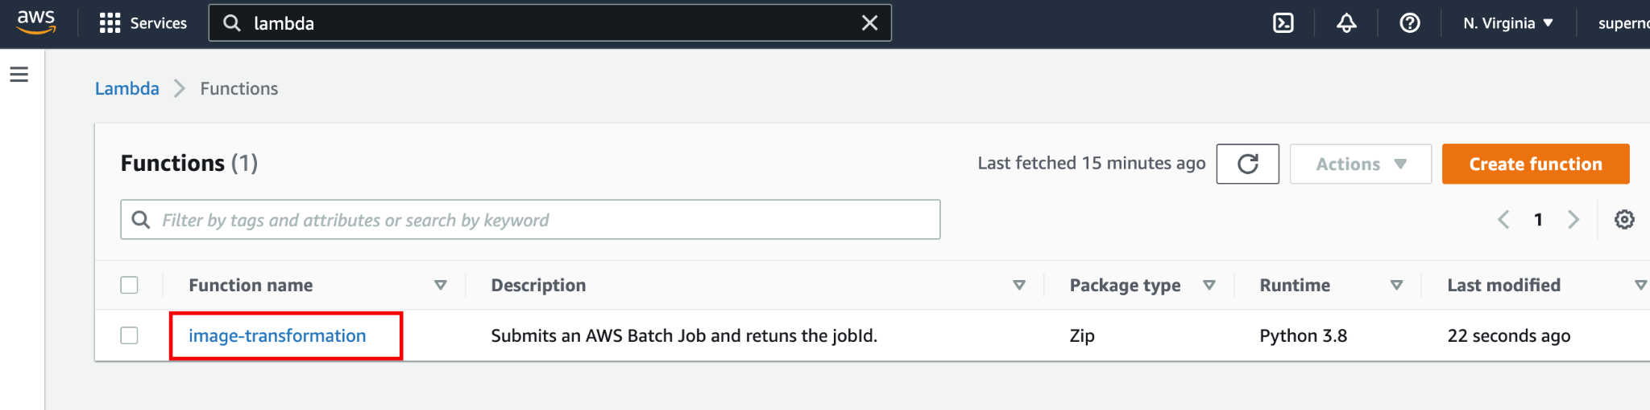

Select Add trigger

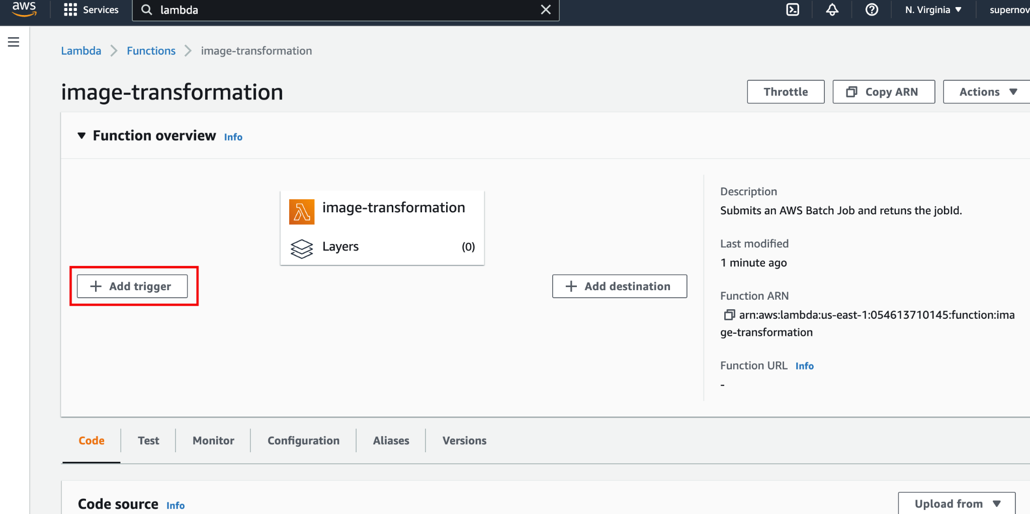

Select S3 as trigger, choosing the input bucket as source and keep All object create event.

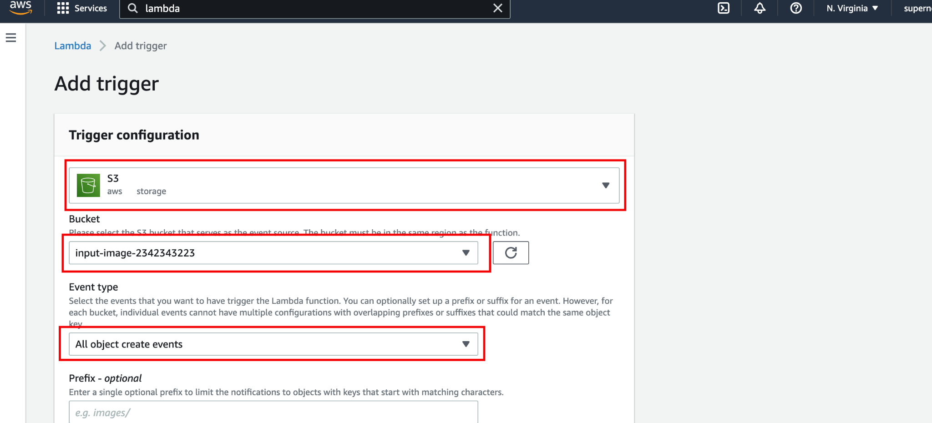

Acknowledge the potential recursive S3 action and click in Add

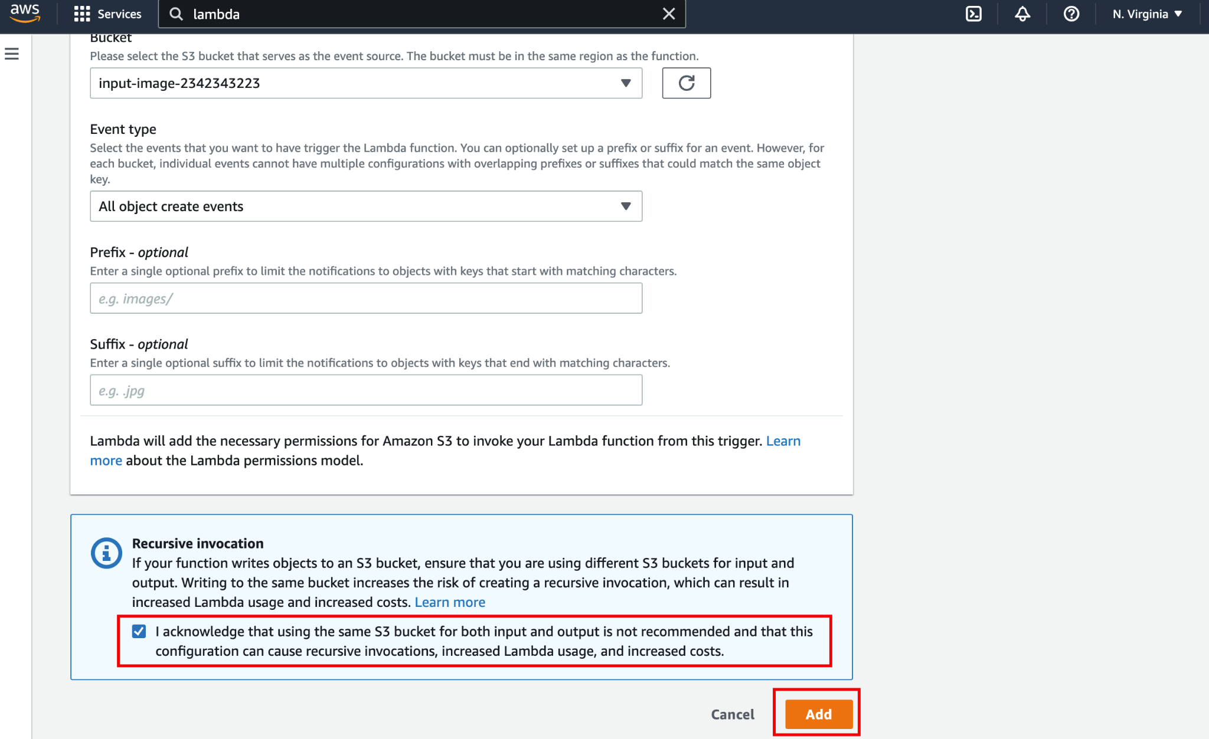

Time to upload the code. Click in Code tab, Upload from and .zip file.

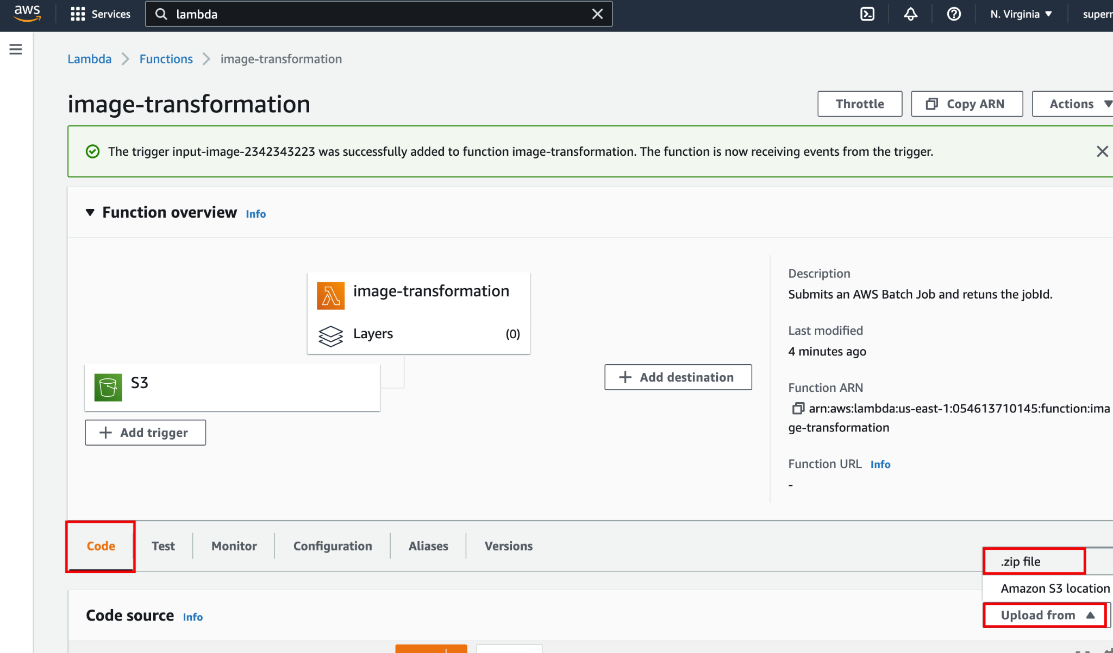

Click in Upload button.

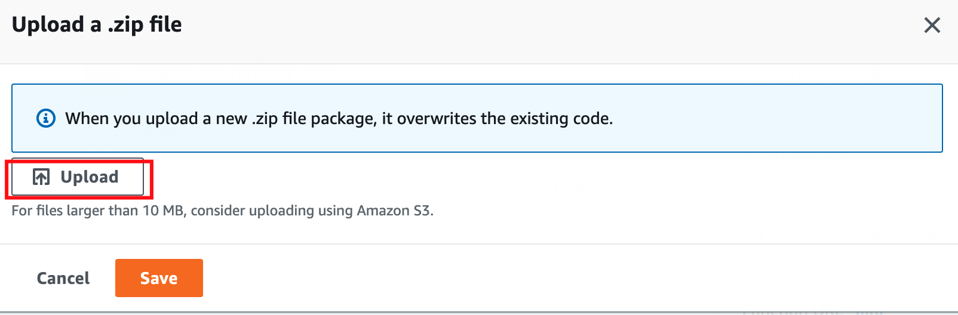

Select the lambda_function.zip file downloaded previously and hit OK

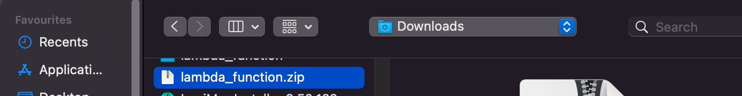

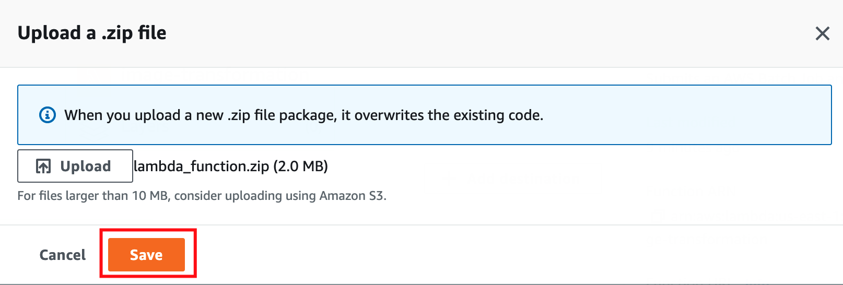

Now it's time to edit the IAM role, adding the missing permissions

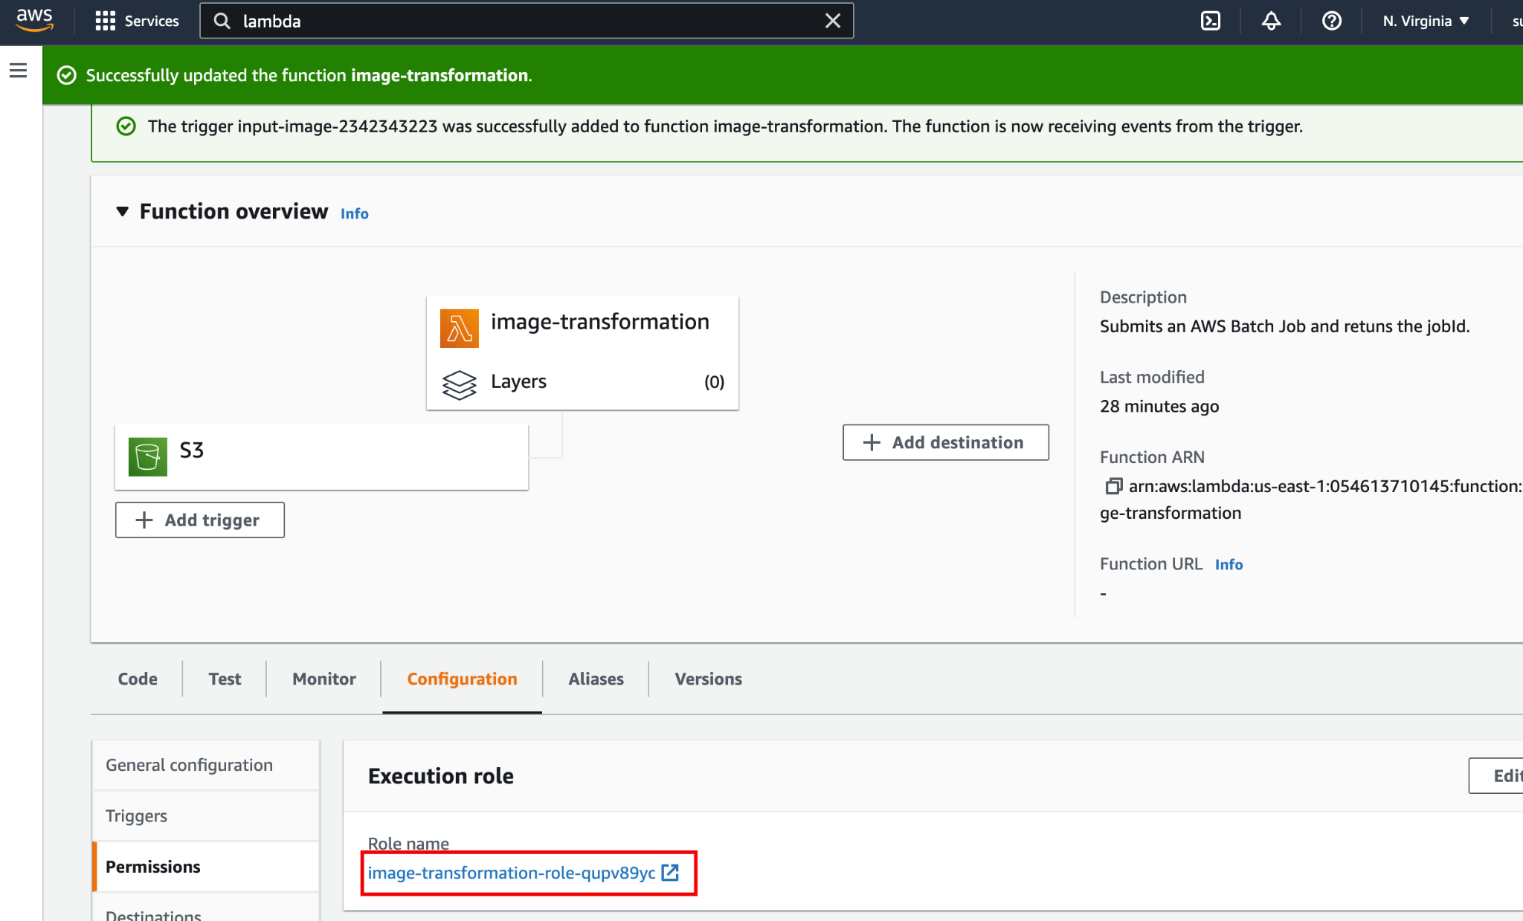

Select Add permissions and Add policies.

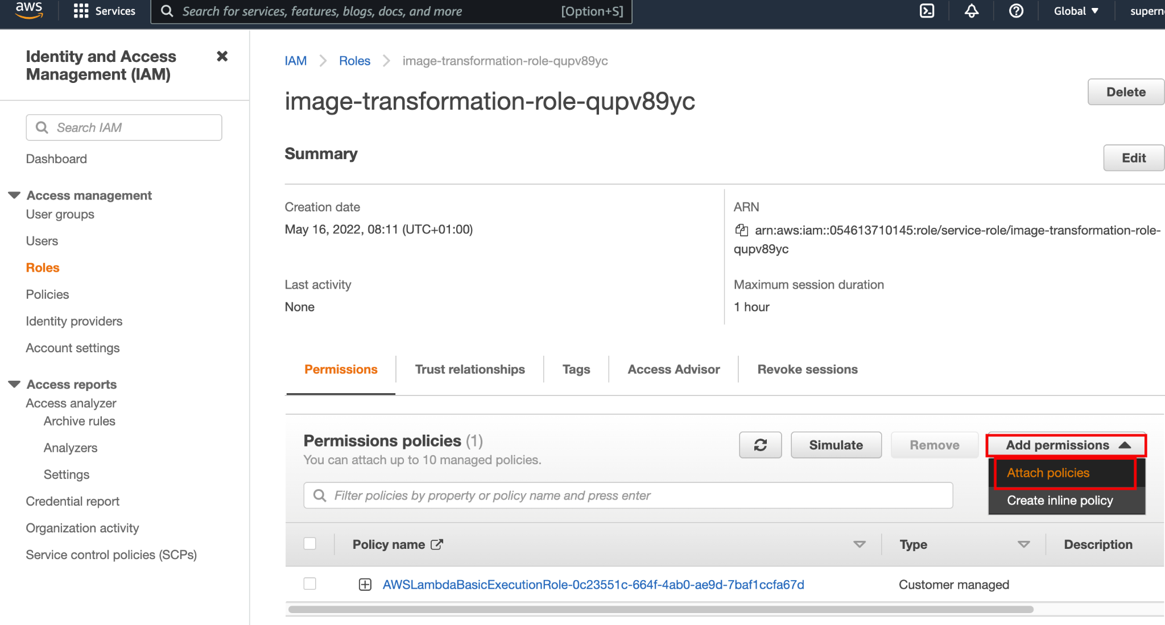

Attach the previous policy created before and click in Attach policy

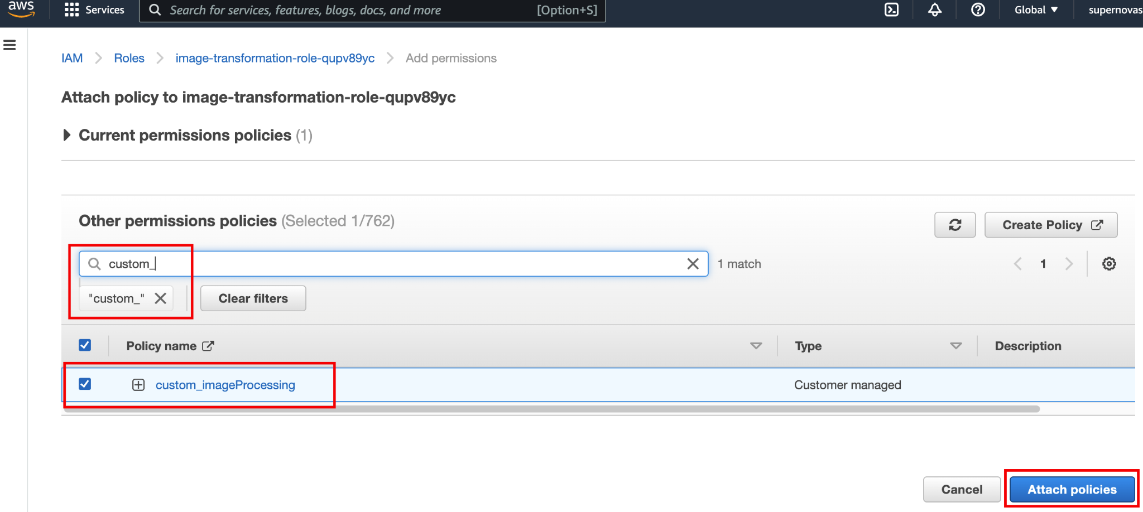

1. Now it's time to test the function. You can use a sample file available here: . Open the S3 console and add the file to the input bucket.

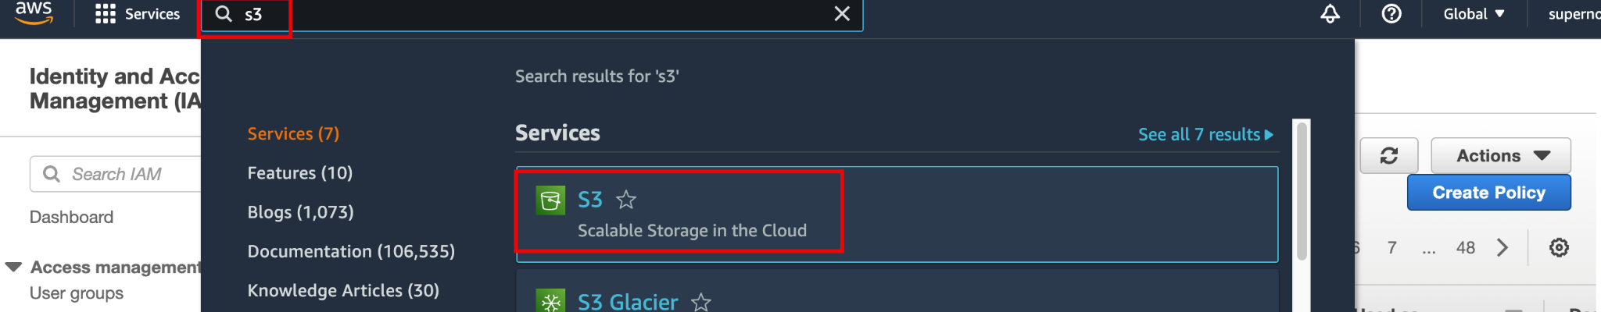

Open the input bucket

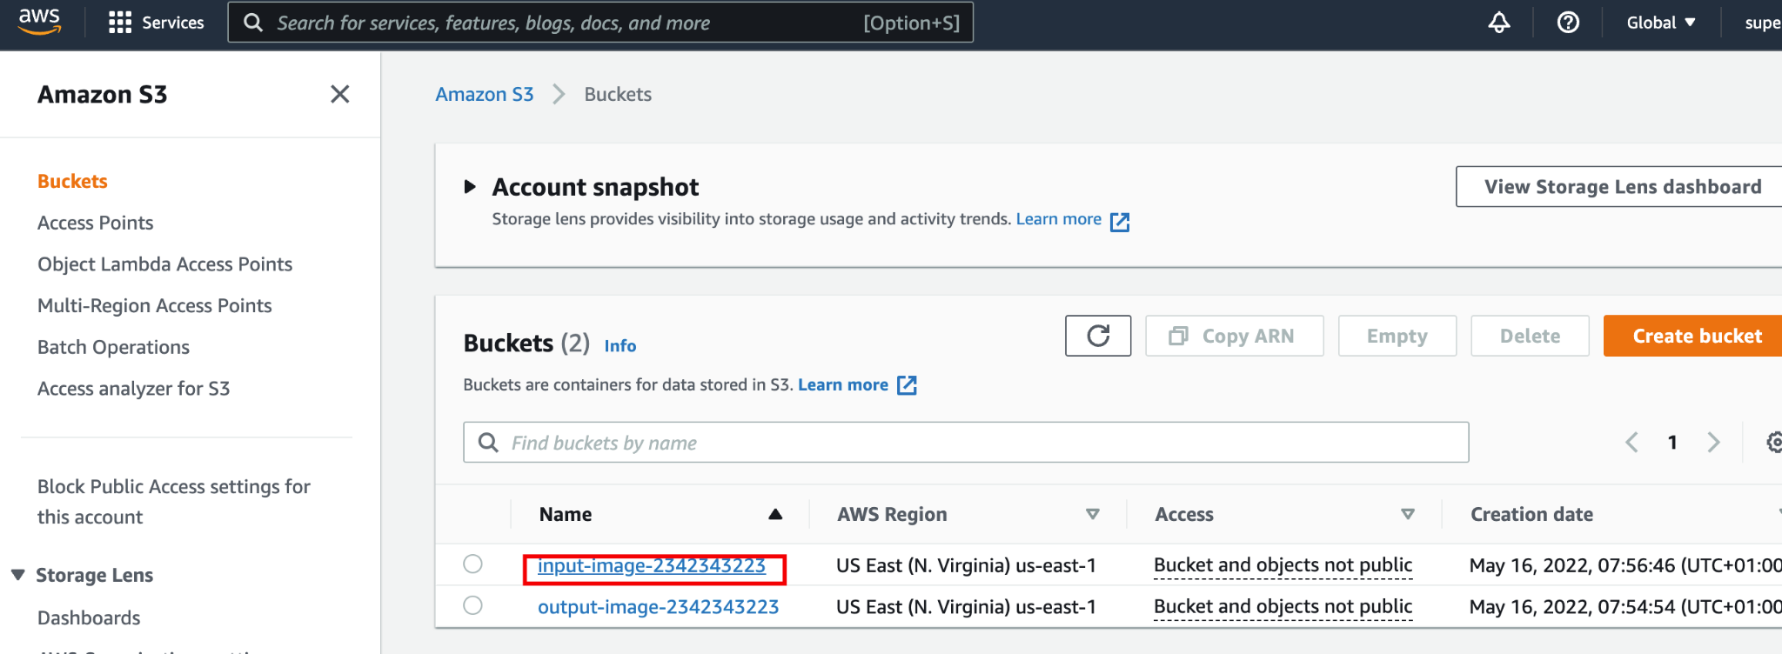

Click in the Upload button

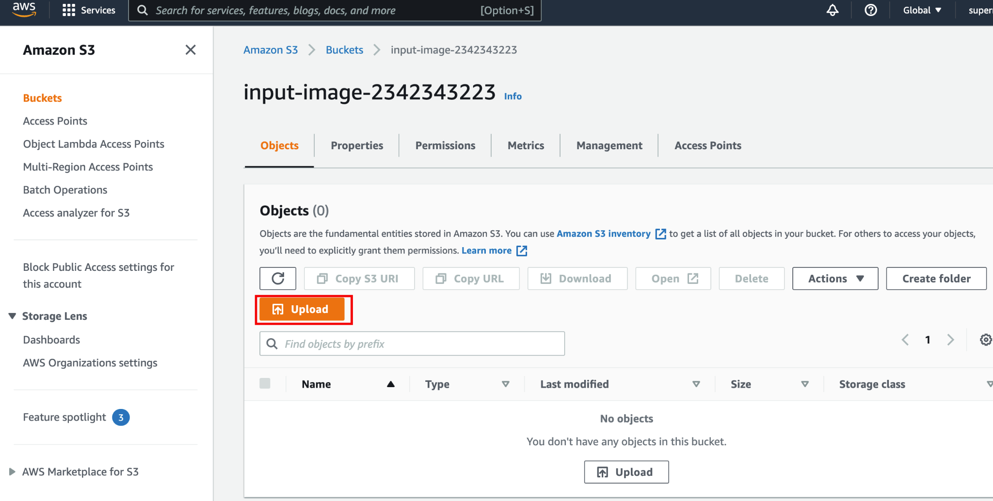

Click in Add file and select a camera image

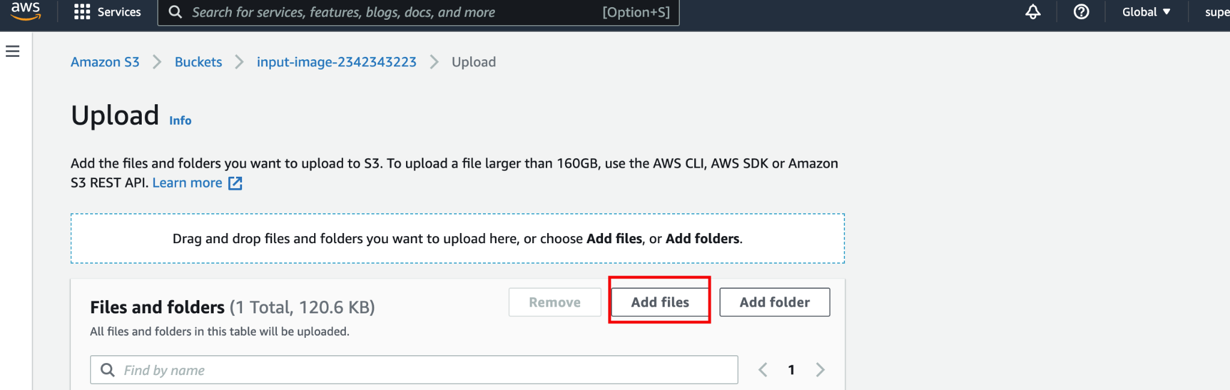

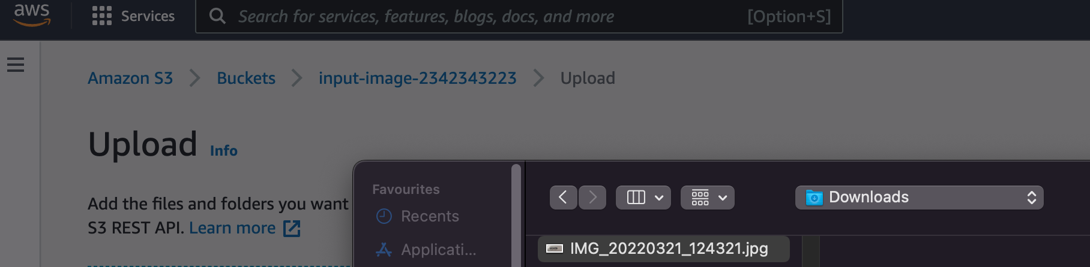

Click in Upload

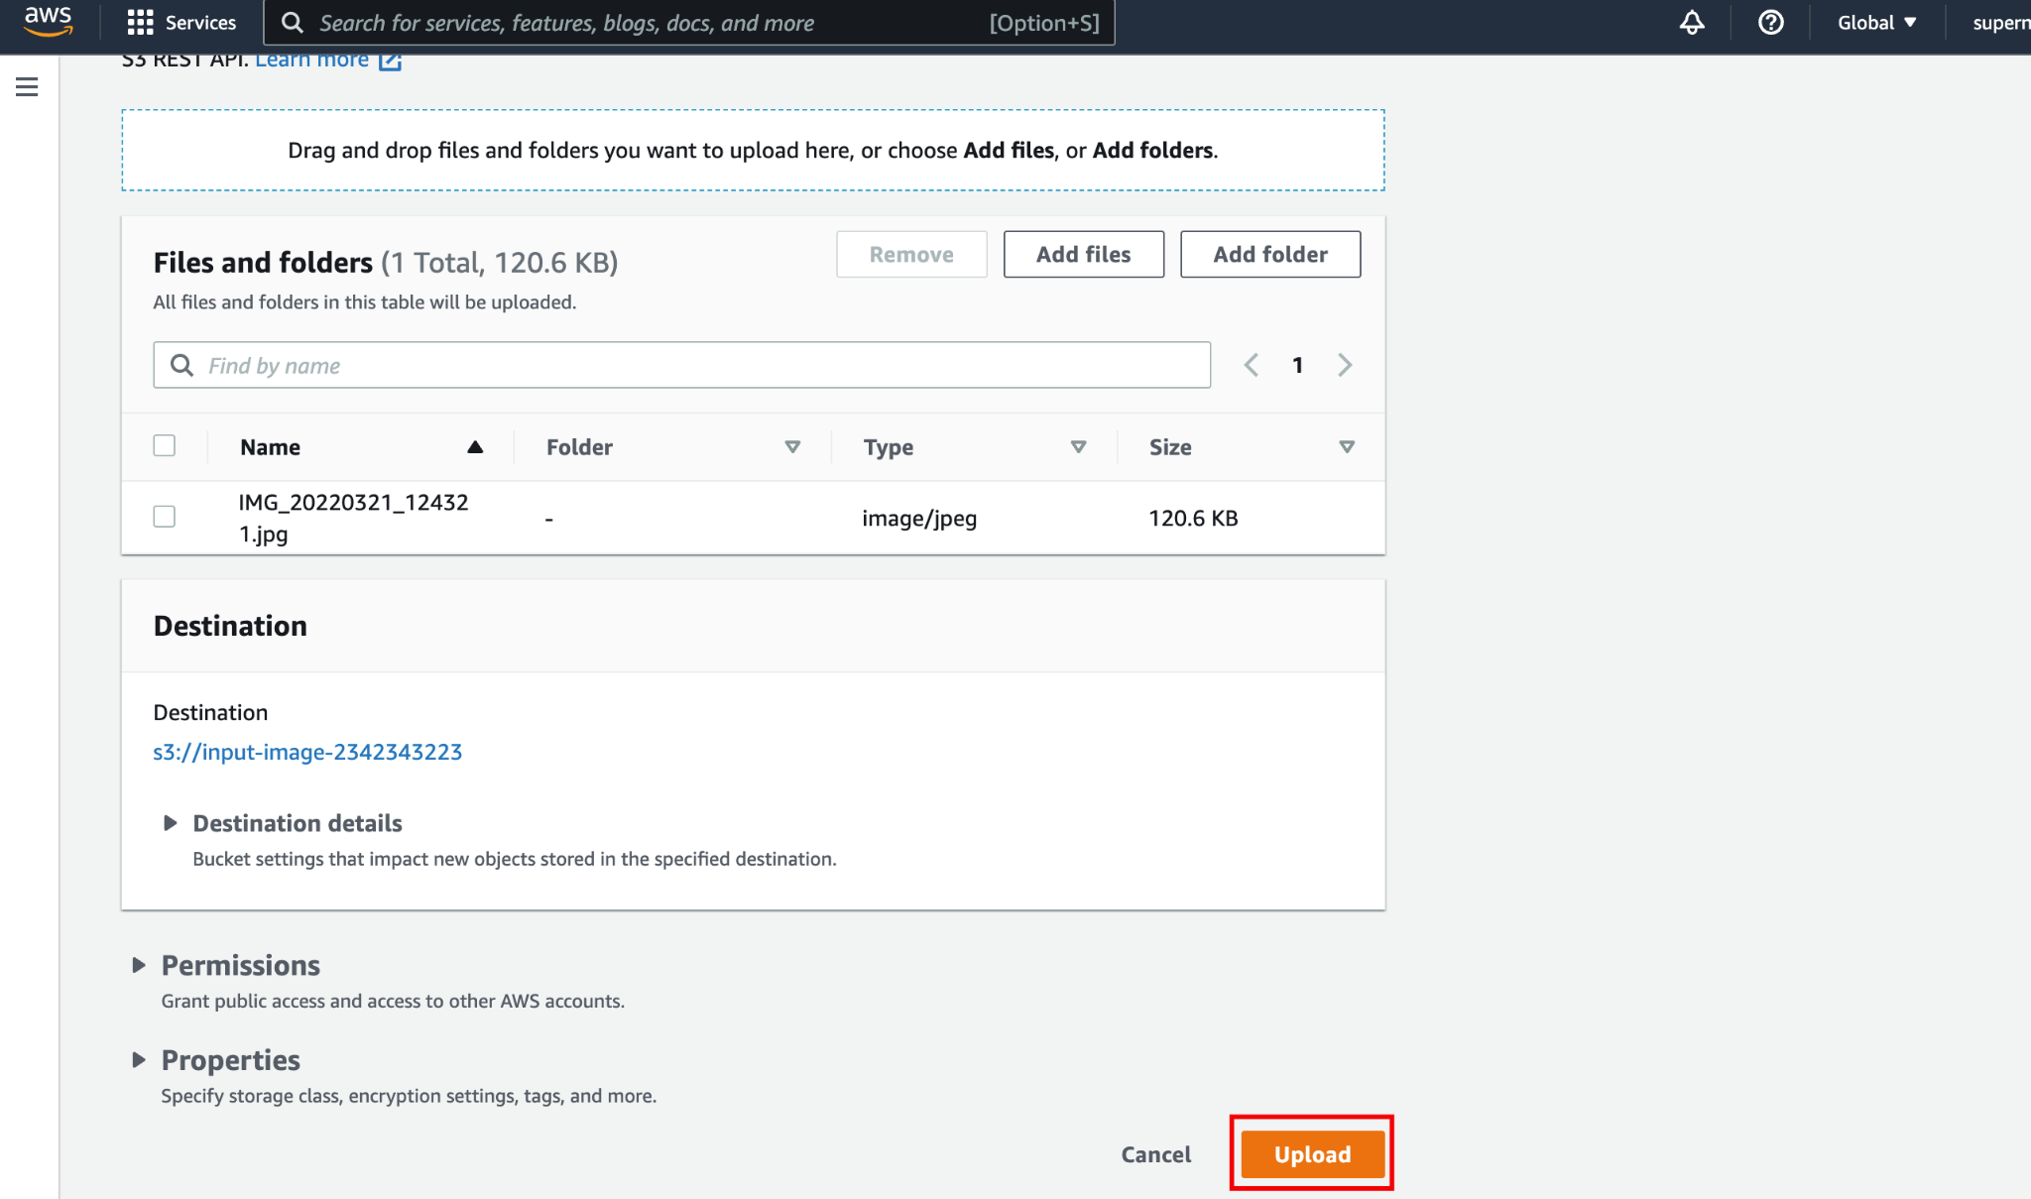

After a minute, you can check the output bucket that a file started with "clean…" will be in there.

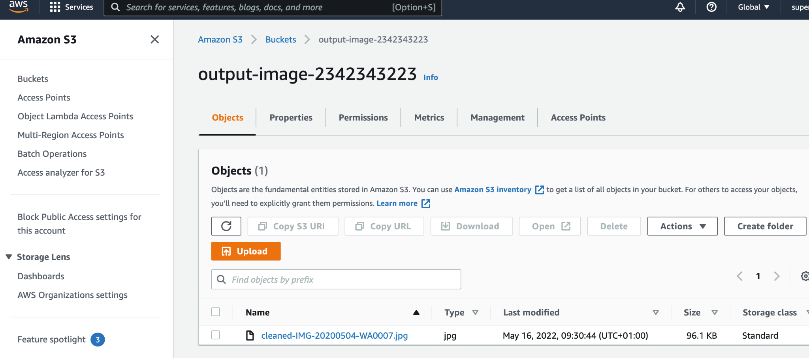

You can download this file and compare the results with the initial image with the previous one using <https://jimpl.com/>

1. The function logs can be checked here

